**Assignment - 3**

|  |  |
| --- | --- |
| Assignment Date | 28 October 2022 |
| Student Name | Karan R |
| Team ID | PNT2022TMID31186 |
| Maximum Marks | 2Marks |

**1.Create a bucket in object storage.**

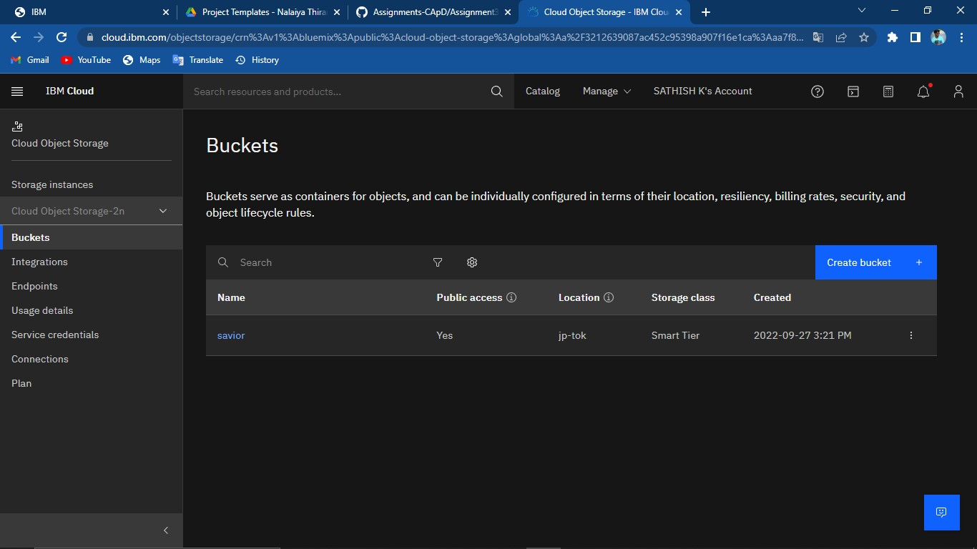

**2.Upload an 5 images to ibm object storage and make it public.Write html code to diplaying the all 5 images.**

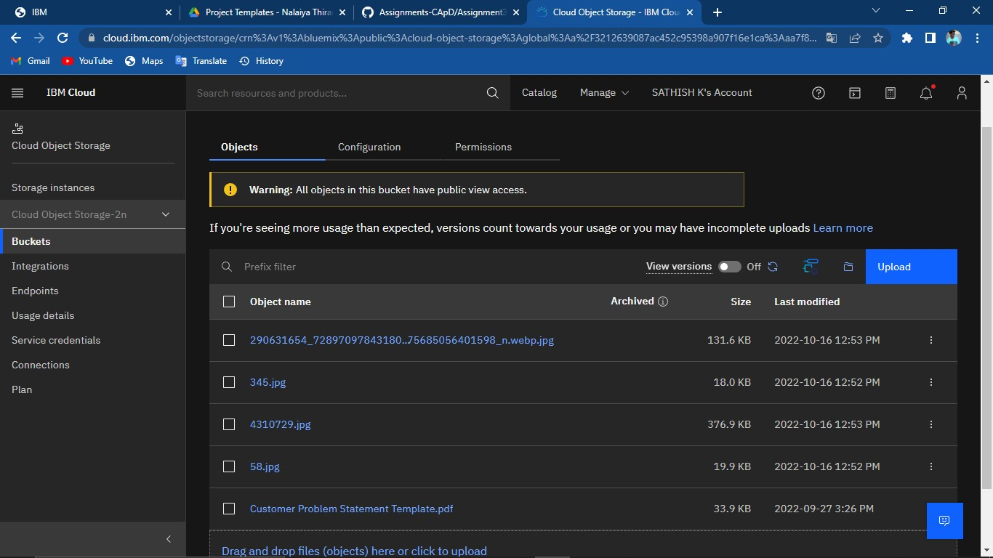

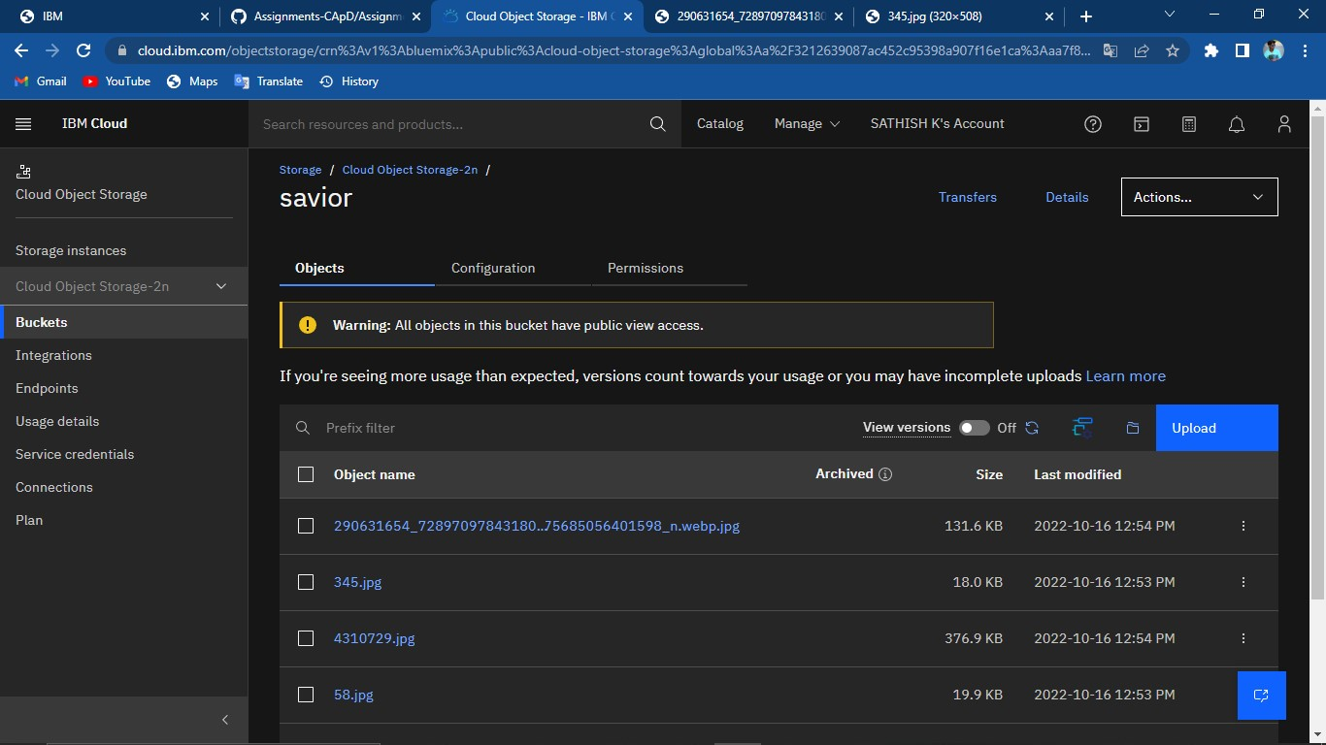

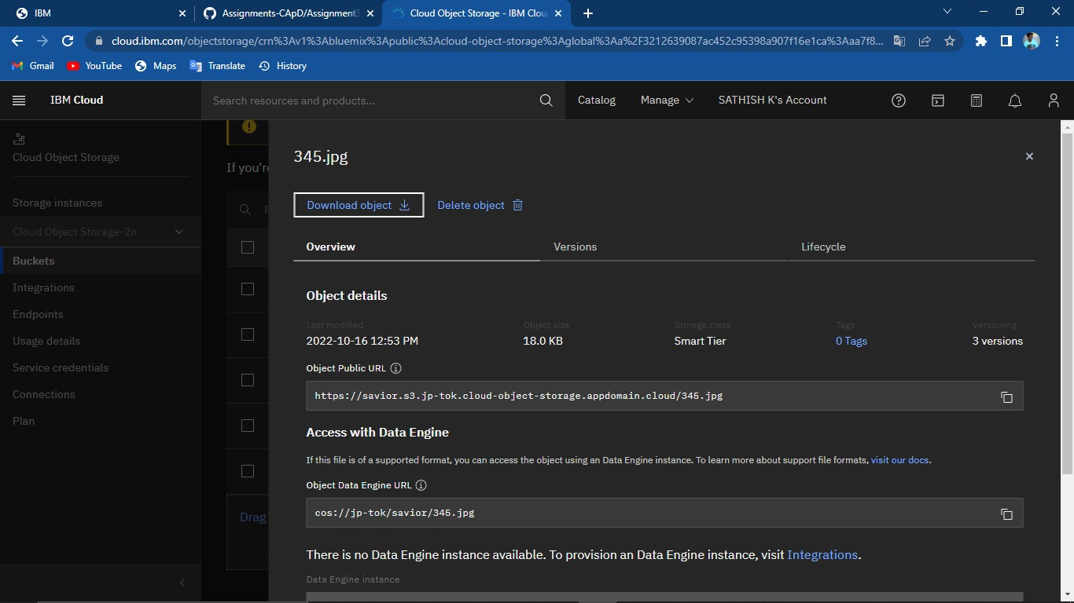

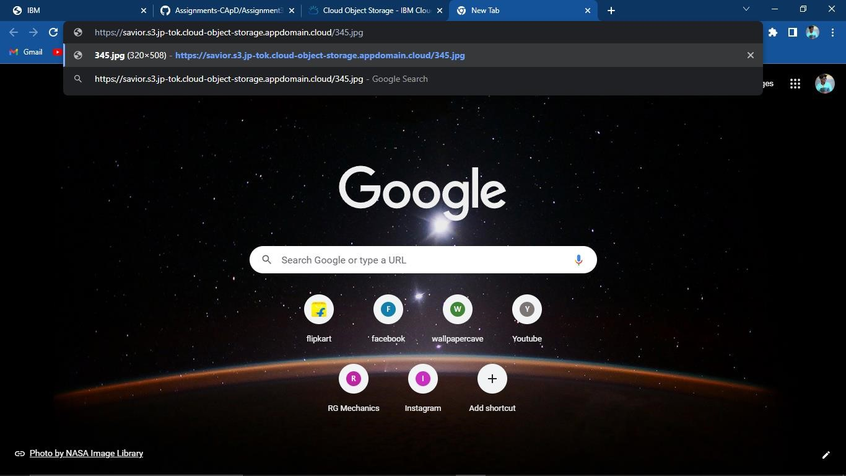

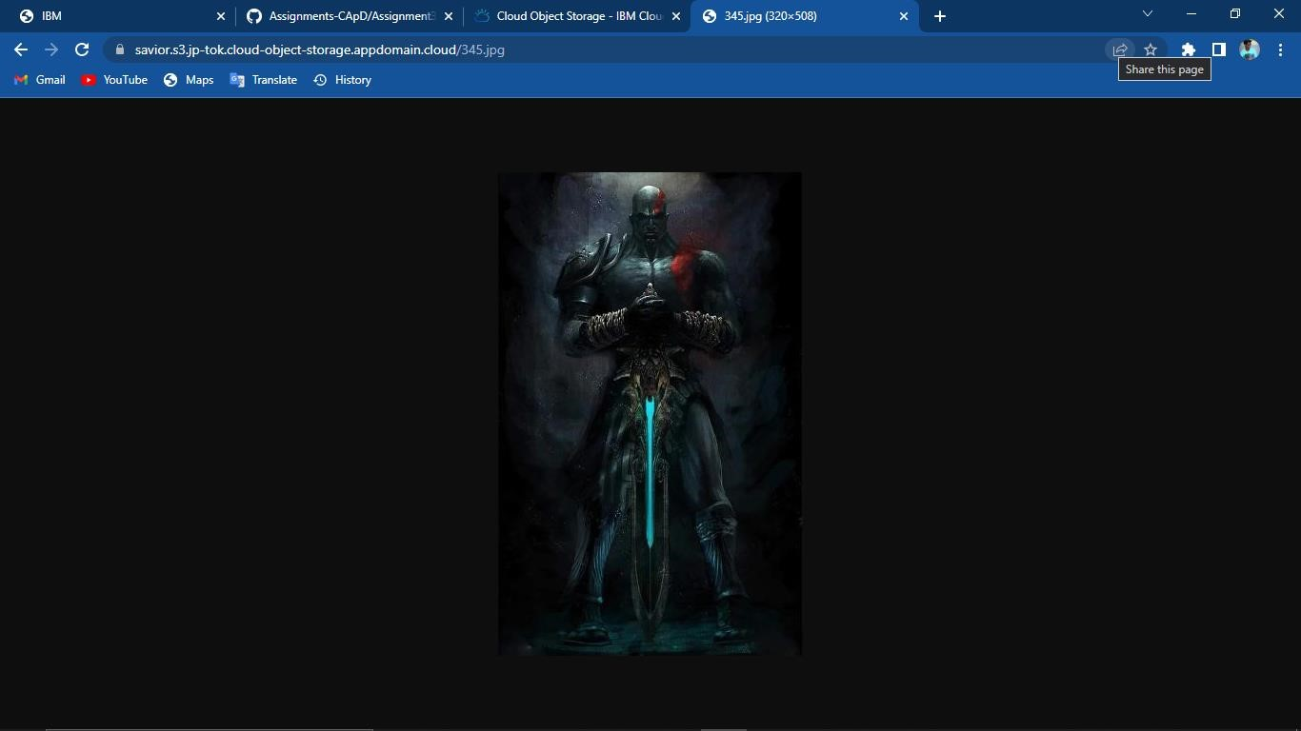

Html code:

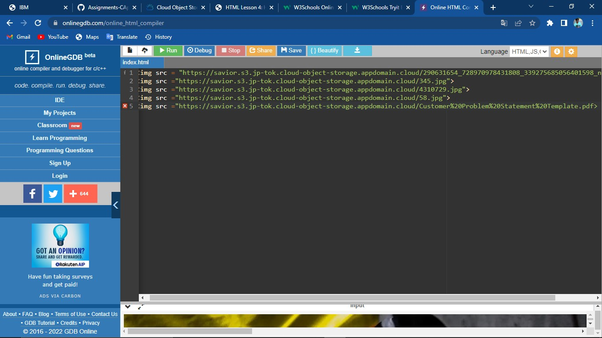

Output:

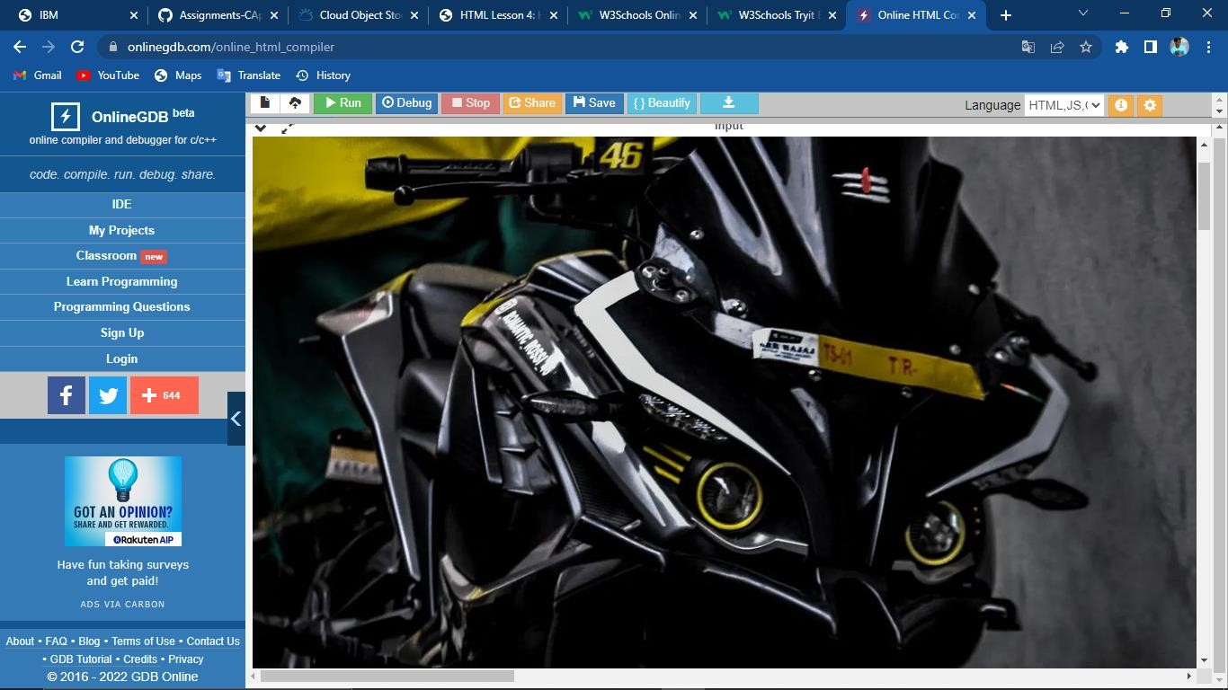

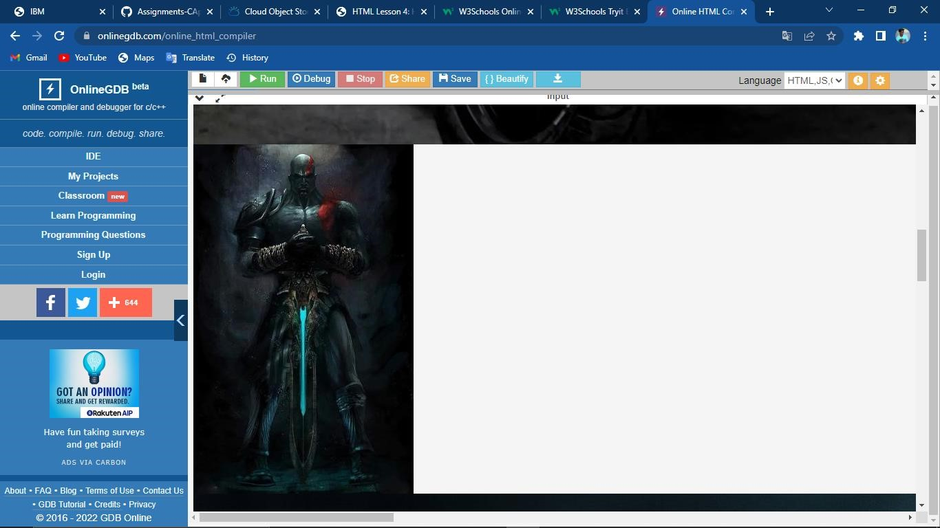

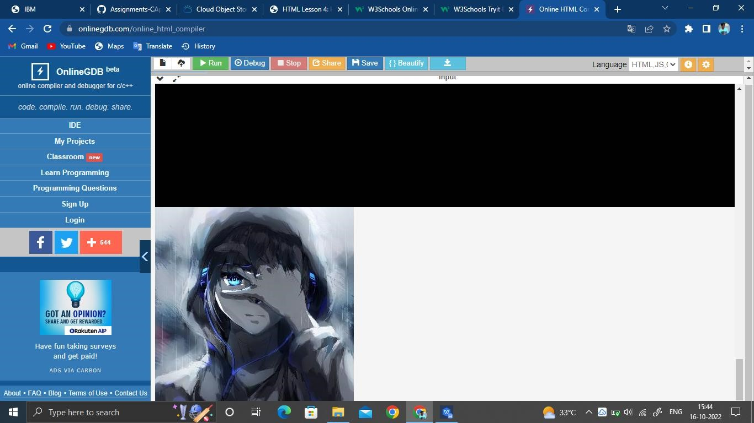

**3.Upload css page to the object storage and use the same page in your html code:**

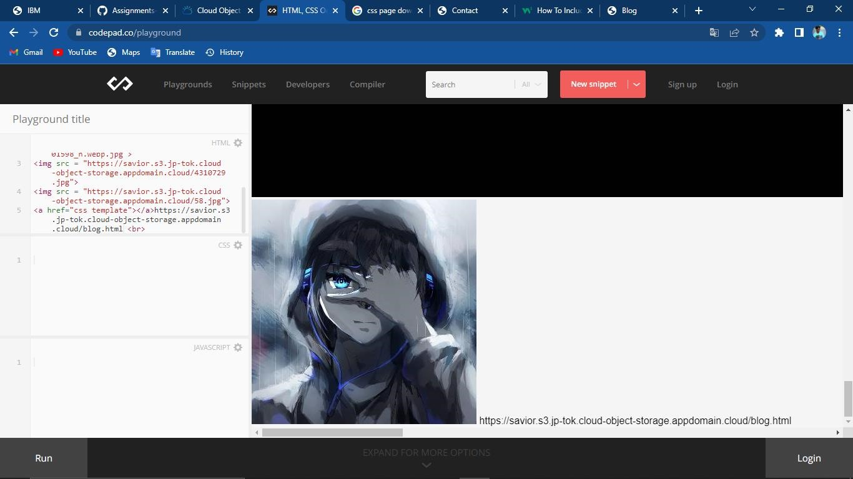

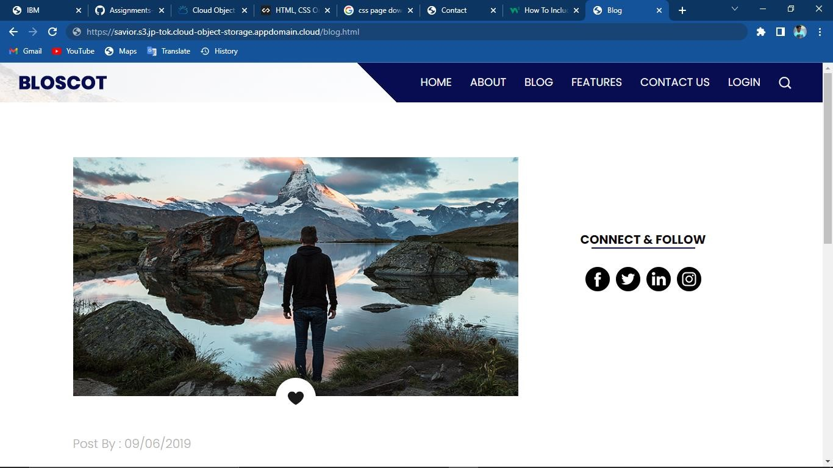

4.Design a chatbot using IBM Watson assistant for hospital.

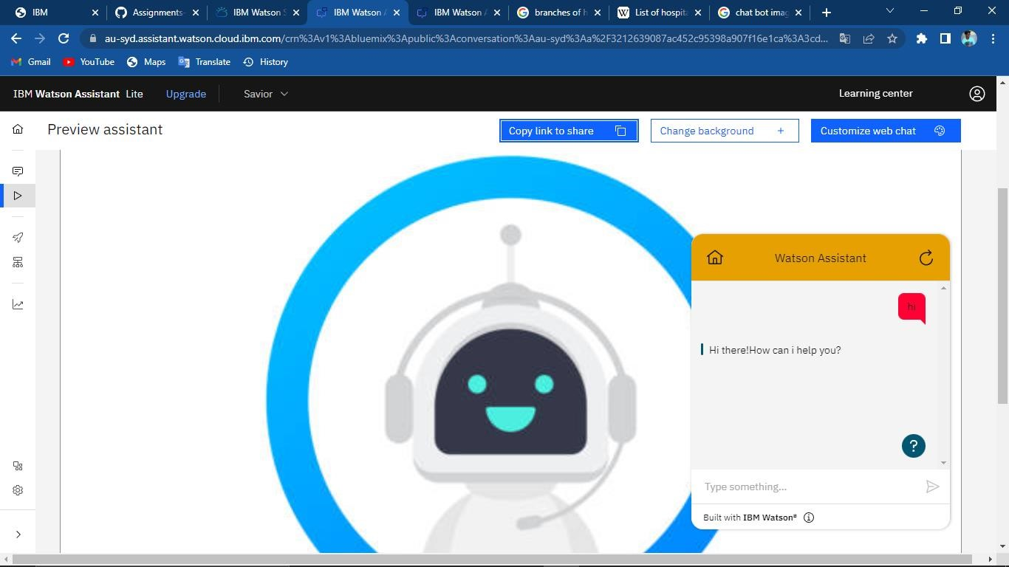

Chat bot link:

https://web-

chat.global.assistant.watson.appdomain.cloud/preview.html?backgroundImageUR L=https%3A%2F%2Fau-

syd.assistant.watson.cloud.ibm.com%2Fpublic%2Fimages%2Fupx-3cd655a11b78-48dc-ab20-337c94b88647%3A%3Ade7378dc-1145-4a02-a22bc41465415808&integrationID=090b01c7-21ab-41fa-9911-

bea3a93c7f8e&region=au-syd&serviceInstanceID=3cd655a1-1b78-48dc-ab20337c94b88647

**5.Create watson service assistant with 10 steps and use 3 conditions in it.Load that script in that HTML page.**